This problem will be worth 13 points You will write two methods in the CubeIt class. The two methods are isPossible( int t, int f, int r) and getRightSide(int top, int front). The CubeIt class has a single constructor that takes a single int[] containing six values {1 – 6} representing a 6 sided die.

The getRightSide(int top, int front) returns the value on the right side of the die with the given top and front values. If it is not possible for the die to have both the given top and front value, return -1.

The isPossible(int top, int front, int right) returns a boolean value indicating if the configuration is possible. That is, it will return true if it is possible for the top of the dice to equal top, and the front of the die to equal front and the right side of the die to equal right. And return false otherwise.

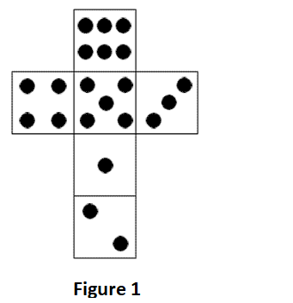
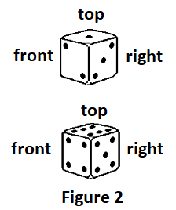
For example, the image in Figure 1 is a standard 6-sided die and can be represented:
new int[] {6, 4, 5, 3, 1, 2};

The dice in Figure 2 are two possible images of the top, front and right side of the standard 6 sided dice.

The following sample code uses a standard 6-sided die.

The following code shows the results of the getRightSide(int top, int front) method.
The following code | Returns
CubeIt c = new CubeIt( new int[] {6, 4, 5, 3, 1, 2});
c.getRightSide(1, 2); | 3
c.getRightSide(6, 4); | 5

The following code shows the results of the isPossible(int top, int front, int right) method.
The following code | Returns
CubeIt c = new CubeIt( new int[] {6, 4, 5, 3, 1, 2});
c.isPossible(6, 4, 5); | true
c.isPossible(1, 2, 3); | true
The image in Figure 3 is represented by: new int[] {1, 2, 3, 4, 5, 6} and represents a 6-sided die.

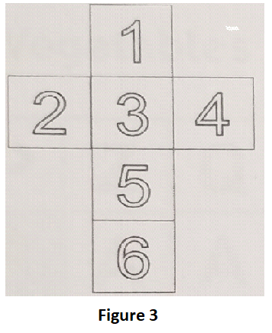

The die in Figure 4 is NOT a possible image of the top, front and right side of the 6 sided dice from figure 3.

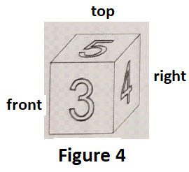

The following code shows the results of the getRightSide(int top, int front) method.
The following code | Returns
CubeIt c = new CubeIt( new int[] {1, 2, 3, 4, 5, 6});
c.getRightSide(5, 3); | 2

The following code shows the results of the isPossible(int top, int front, int right) method.
The following code | Returns
CubeIt c = new CubeIt( new int[] {1, 2, 3, 4, 5, 6});
c.isPossible(5, 3, 4); | false
c.isPossible(5, 3, 2); | True

One more example on next page
One last example, Figure 5 is example of a 6 sided die represented by: new int[] {1, 5, 2, 6, 3, 4};

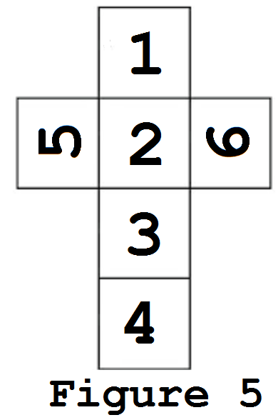

The following code shows the results of the getRightSide(int top, int front) method.
The following code | Returns
CubeIt c = new CubeIt( new int[] {1, 5, 2, 6, 3, 4});
c.getRightSide(1, 2); | 6
c.getRightSide(5, 2); | 1
c.getRightSide(5, 6);  // remember to return -1 if it is not possible for 5 to be on top and 6 in front. | -1

The following code shows the results of the isPossible(int top, int front, int right) method.
The following code | Returns
CubeIt c = new CubeIt( new int[] {1, 5, 2, 6, 3, 4});
c.isPossible(1, 2, 6); | true
c.isPossible(5, 2, 1); | true
c.isPossible(4, 1, 6); | true

